# Corporation of the City of Clarence-Rockland

## By-law 2025-XX

### Being a By-law to amend Zoning By-law No. 2016-10.

Whereas Zoning By-Law no. 2016-10 regulates the use of land, and the use and construction of buildings and structures in the City of Clarence-Rockland; and

Whereas the Council of the Corporation of the City of Clarence-Rockland considers appropriate to amend Zoning By-Law No. 2016-10, as described;

Now therefore, the Council of the Corporation of the City of Clarence-Rockland enacts as follows:

1. The subject property is the severed parcel of consent file B-074-2024, which consists of Part of Lot 24, Concession 3 identified on Schedule “A” attached to and forming part of this by-law shall be the lands affected by this by-law.
2. Zoning Map “A” of Zoning By-Law No. 2016-10 is hereby amended by changing the subject property from from “Agricultural (AG) Zone” to “Agricultural – Exception 15 (AG-15) Zone” for the severed parcel of consent file B-074-2024 as identified on Schedule “A” of the map attached hereto and fully integrated as part of this By-law.
3. Section 12.1.3 is amended by modifying subsection (o) to read as follows:

AG-15, Part of Lot 1, Concession 7 (B-CR-007-2011); Part of Lot 1, Concession 7 (B-CR-006-2011); Part of Lot 13, Concession 9;

Part of Lot 9, Concession 10; Part of Lot 4, Concession 4; Part of Lot 9, Concession 5; Part of lot 2, Concession 3; Part of Lot 1, Concession 6 (D-10-22-13), Part of Lot 24, Concession 3 (severed parcel of consent B-074-2024)  
  
Notwithstanding the provisions of this By-law to the contrary, the lands zoned AG-15, prohibit residential uses and permit agricultural uses on a lot having a minimum lot area inferior to 20 hectares.

1. This By-law shall become effective on the date of passing hereof, subject to the approval of the Tribunal or following the last date for filling objections as the case may be.

Read, passed and adopted in open council this 14 day of May 2025.

Mario Zanth, Mayor Monique Ouellet, Clerk

## Explanatory Note

### Purpose and Effects of this By-Law

The purpose of the by-law is to change the zoning category of the severed parcel of the property subject of consent file B-074-2024 as a condition of granting the severance. The zoning of the severed parcel would change from “Agricultural (AG) Zone” to “Agricultural – Exception 15 (AG-15) Zone” in order prohibit residential uses and permit agricultural uses on a lot having a minimum lot area inferior to 20 hectares.

For further information concerning this amendment to Zoning By-Law No. 2016-10, you may contact the Planning Division of the Community Development Department, at the Town Hall, which coordinates are 1560 Laurier Street, Rockland or by telephone at (613) 446-6022.

## Schedule A to By-law 2025-XX

### Certificate of Authentication

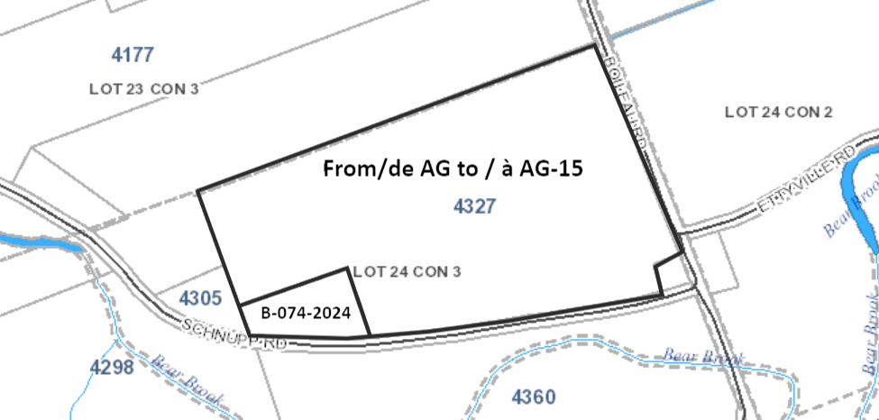

Lot with bold border: Zone change from AG to AG-15 (severed parcel of severance file B-074-2024).

Not to scale

This is plan Schedule A to Zoning By-Law amendment 2025-XX, passed the 14 day of May 2025.

Part of Lot 24, Concession 3

Prepared by the City of Clarence-Rockland

1560, Laurier Street, Rockland, Ontario K4K 1P7

Mario Zanth, Mayor Monique Ouellet, Clerk